Case Analysis on Chic Fil A
Student Name
Institutional Affiliation
Due Date

Table of Contents
Table of Contents
Table of Contents 2
Introduction and Key Issues 3
External Analysis 4
Porter’s 5/6 Forces Analysis 4
Suppliers 4
Clients 5
Competitors 5
Entry Barriers 5
Product substitute 6
Macro Environmental Analysis 6
Political Factors 6
Economic Factors 6
Social Factors 7
Technological Factors 7
Internal Analysis 7
Analysis of Business-level Positioning Strategy 9
Analysis of the Corporate-level Strategy 10
Recommendations 11
References 12

Introduction and Key Issues
Chic Fil A is one of the biggest fast-food restaurants in America. It specializes in chicken sandwiches. The company’s headquarters are located in College Park, Georgia. The company runs over 2,769 restaurants in the United States and has plans of opening other restaurants. The restaurants serve their customers' breakfast, lunch, and dinner. The company also provides outside catering services to its customers during special occasions. The company’s business strategy focuses on a small menu by maintaining its focus on chicken sandwiches unlike many of the fast-food businesses which focus on a variety of items to attract customers. The company is founded under strong religious beliefs and all its restaurants do not operate on Sundays, Thanksgiving, and Christmas day (Slaughter, 2020). It is also an international company located in other parts outside the US including Canada, South Africa, and the United Kingdom.
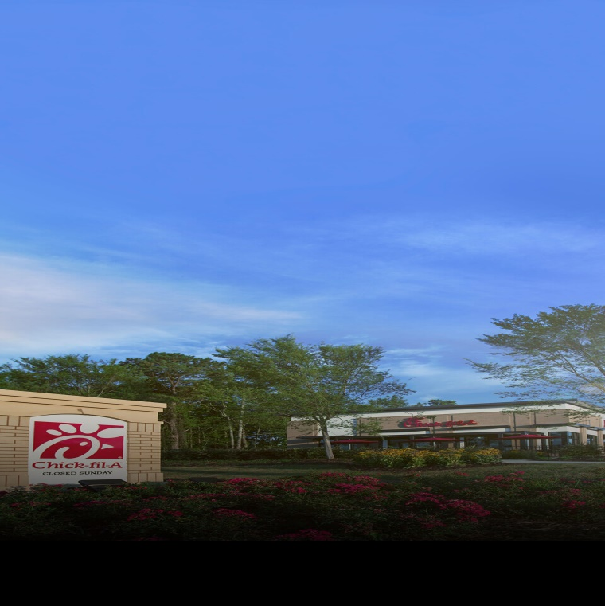
Fig 1: A picture of Chick-fil-A
Chick-fil-A is faced with the issue of the supply chain as it restricts its popular sauces. The company has therefore been forced to limit sauces to one per unit in some of its locations. Chick-fil-A is the most current company to encounter supply chain issues over products. The company has been restricted its most popular sauces forcing them to also restrict the sauces to one per unit. This issue has been a result of a shortage of items in the supply chain based in Atlanta. The company reported that it apologized for the inconveniences to its customers caused by shortages in the industry’s supply chain making some products such as sauces inaccessible (Duggan & McMurtrey, 2021). This shortage has led to an increase in the price of the limited items. However, the company has not been affected by the shortage of chicken.

External Analysis

Porter’s 5/6 Forces Analysis
Porter’s 6 forces is a critical tool that is used by companies to evaluate and research markets to help in designing sufficient strategies. It is an expansion of Porter’s 5 forces. Porter’s 5 forces include suppliers, clients, competitors, entry barriers, and product substitutes while Porter’s 6 forces have added an extra element of complementary products (Wu et al. 2012).

Suppliers
The chicken suppliers of Chick-fil-a company include Perdue Farms, Sanderson Farms, Tyson Foods, and Pilgrim’s Pride. These are among its top 17 chicken suppliers. The company intends to use these suppliers for allegedly raising the prices. The company is also transparent and responsible for how they choose their suppliers and therefore its customers can trust them. The company sources its ingredients from companies that provide ingredients of high quality and that follow their standards. Other examples of their suppliers include a Bushel and a Peck for apple supplies and Thrive farmers for coffee supplies. Most of the company’s supplies are grown and raised in the United States farms. Chick-fil-a usually ensures that their suppliers follow unvarying quality and safety standards. The company also visits its major suppliers and has established strong relationships with its suppliers.

Clients
The customers of Chick-fil-A are mostly middle and upper-class customers. They include moms, families, and millennials. However, the primary target customers of the company are the middle class and any other class of people commuting within their location and requiring fast food. Most of the customers are whites aged between 45 and 54 years, either adult or young couples. This is according to the data given by the company’s analytics.

Competitors
Chick-fil-A faces competition from companies such as KFC, Wendy’s, McDonald’s, Fogo de Chao, and Taco Bell. The CEO of Chick-fil-A is ranked first among its competitors. The product quality score of Chick-fil-A is rated at 4.6 out of 5 making it the first among the competitors. The net promoter score of the company is rated at 72, which places it first among its competitors. Chick-fil-A, therefore, dominates its main competitors and has a strong competitive advantage.

Entry Barriers
Companies are more likely to face the threat of new entrants into the market specifically in the food industry. New entrants can be successful as long as they understand the needs of the customers and advance their products more than their rivals to meet customer requirements. Chick-Fil-A faces a low threat of new entrants because it has established a wide network around the world.

Product substitute
Chick-fil-A faces a high threat of product substitutes. This is because there are options for replacing some of its products including nestle products such as pasteurized milk and boiled water. The company also faces a threat of reduced sales of some of its products due to claims of the particular products being unsafe for use. However, the company has started displaying some of their products’ health advantages as a way of dealing with the substitutes.

Macro Environmental Analysis
Macro environmental analysis of Chick-fil-A Company will include an analysis of the external environment chances to enter and extend to Saudi Arabian markets. The analysis includes the macro-environmental forces of economic, social, political, and technology in Saudi Arabia (Radwan, 2018).

Political Factors
Saudi Arabia has one of the fastest enlarging food industries in the Middle East. It has maintained promising and resilient growth for more than a decade. The stakeholders of the industry including the government have made efforts to constantly improve their standards and to ensure that the industry obtains international authorization for food quality. The political environment in Saudi Arabia is therefore favorable for Chick-Fil-A to establish their business in the country.

Economic Factors
This is the most important factor when making decisions about accessing new markets. The economy of Saudi Arabia has one of the highest incomes with a GDP of $1.7 trillion and a growth rate of 3.4%. It also has the best rate of inflation standing at 2.2% by the year 2016 while the unemployment rate is at 5.8%. The economic freedom in Saudi Arabia is 64.4 which exceeds the global average economic freedom of 60.9. The economic environment in Saudi Arabia is therefore favorable for a fast-food business.

Social Factors
Saudi Arabia’s social environment was at first suspicious about fast foods due to religious beliefs. However, this perception changed after the opening of the international markets or fast foods. Research shows that most school-going children consume fast foods. The high prevalence of obesity in Saudi Arabia symbolizes the high consumption of fast foods. Saudi Arabia is, therefore, a perfect market for fast foods.

Technological Factors
Saudi Arabia is focusing on investing in technology in the food industry. The use of technology will ensure good customer service because it will save on their effort and time. Research shows that 42% of Saudi Arabians trust digital platforms to order food and that 80% of these residents use their mobiles to order food. This will give Chick-fil-A a good business opportunity.

Internal Analysis
According to the SWOT Analysis, some of the strengths of Chick-fil-A include that the company is one of the well-established fast food industries in the United States with over 2500 restaurants across all the US states. The company also has prosperous advertising strategies such as the “Eat Mor Chikin” campaign which has helped the company’s brand to grow (Uttakalla et al. 2017). Chick-fil-A has sponsored many sporting events which have helped in creating awareness of their brands. The company is also well-known for its specialization in chicken sandwiches and other dishes. Chick-fil-A has enhanced its reach by enabling online orders and deliveries. Chick-fil-A is also established outside the United States and it is present in South Africa, the UK, and Canada. Finally, Chick-fil-A has an ad turnover of around $10 billion. The company also has its weaknesses. First, Chick-fil-A is dominated in the United States and therefore lacks an international presence. Another weakness is that the company experiences high competition which limits the market share.
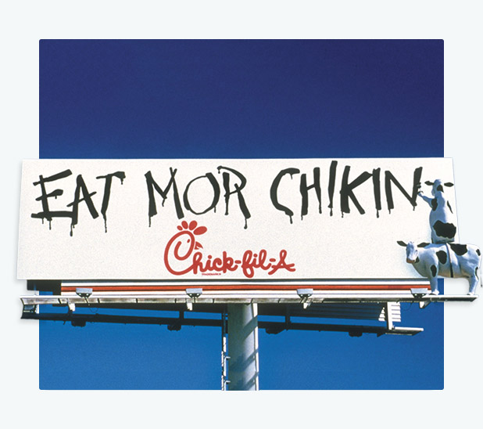
Fig 2: “Eat Mor Chickin” Campaign
Chick-fil-A has created a strong competitive advantage by producing a superior product that is quality and differentiated. The company’s chicken sandwiches are prepared using a unique and perfect recipe. The company has kept the secret of its recipe such that no other company can produce a similar product making it have a strong competitive advantage. This advantage is sustainable because the company focuses on providing this superior product throughout its operation and also the fact that they have kept their recipe a secret makes the advantage sustainable since the exact chicken sandwiches cannot be produced by other companies. Innovation is one of the core capabilities of Chick-fil-A. This includes the ability to produce unique and superior products and good customer service and the company has used these capabilities as a competitive advantage.
The financial statements of Chick-fil-A show a healthy trend and competition in the fast-food industry. This is because, despite the pandemic, the company has continued to record high revenue and earnings and has been ranked at position 9 among franchise companies in the US. According to the 2020 financial report, the company’s revenue was $4.3 billion compared to $3.8 billion in 2019 which is a 13% increase. Chick-fil-A also reported total earnings of $715.9 million in 2020 compared to $647.2 million in 2019 representing a 10.6% increase (Grem, 2013). This is a healthy financial statement report for the company because it indicates growth. This increasing trend in both revenue and earnings helps the company to maintain its strong competitive advantage.

Analysis of Business-level Positioning Strategy
Chick-fil-A is one of the top fast-food companies in the US. The company has been admired in the fast-food industry for having the highest standard sales per restaurant which are more than that of its major competitors including Mcdonalds' and Wendy’s fast-food companies. Chick-fil-A is the most popular food fast company and has been ranked at the first position out of the fast-food companies in the US with a score of 83/100.
This positioning of Chick-fil-A Company is supported by its functional strategies including its business model, a superior product, customer service, and unique franchise model. Chick-fil-A has implemented a business model that aims at offering chicken products of high quality. The company has been successful because of its operating and business models. The company purposes to produce quality and differentiated products (superior products). It took the company 11 years to create the recipe for the new grilled chicken sandwich. This shows the company’s product is of quality and differentiated product. Chick-fil-A has also established a distinctive franchise model to ensure controlled growth that associates with the goals of the company. Chick-fil-A possesses all of its functional stores, unlike other fast-food companies. The company is also committed to providing a high level of customer service by offering customer service training for all the employees. The company has increased its brand awareness by making some sponsorship for different activities, for example, the company donated $68 million to over 700 educational or charitable organizations (Uttakalla et al. 2017).
This positioning of Chick-fil-A has created a strong competitive advantage for the company. This has helped the company surpass its competitors. It has enabled the company to attain superior achievements including revenue and earnings than its competitors. Being the top fast-food company has also generated great value for the whole company as well as its shareholders. For example, Chick-fil-A makes the highest sales compared to its competitors whereby the 2019 report indicated that the company’s sales were at $11.3 billion compared to Wendy’s, one of its competitors, who made sales worth $9.8 billion.

Analysis of the Corporate-level Strategy
Chick-fil-A is planning to enter a new market in Saudi Arabia by opening a new branch in the country. The company will open an additional fast-food branch that is related to its main product of chicken sandwiches. It is a new market that the company wants to discover. This entry will create additional value for the company because it will have expanded its borders and is also a move towards international recognition. It will place the company in a better competitive advantage.
Chick-fil-A plans to enter its new market based on the 6 aspects of the macro-environment which include economic, political, social, legal, and technology (Radwan, 2018). The political aspects will enable the company to know whether the government of Saudi Arabia supports fast-food businesses. The economic factors give an analysis of the economic environment of the country while social factors help to learn of the people’s perceptions of the particular business. Legal factors include business permits to operate in that particular country. This entry method is the best choice these macro-environmental factors will be used as a strategic market tool to provide information about the new market to help the company in deciding on entering into the new market. The method will also provide Chick-fil-A with recommendations on how to survive and maintain a strong competitive advantage in the Saudi Arabian market.

Recommendations
The Chick-fil-A company should work towards making adjustments to solve the supply chain issue which is the major issue facing the company. The company needs to implement demand forecasting software to avoid such issues from happening. This will help in forecasting future demands to help in planning. The company is performing well in its other operations. However, the company may improve the performance of its employees by using digital scheduling, training, and quizzing. These strategies will ensure that the company remains at top of the rest of the fast foods companies as well as maintain its sustainability.

References
Uttakalla, S., Walger, I., & Wu, C. H. K. (2017). Case Study: Chick-fil-A Team 7-The Bootstrappers: Alicia Fowler Christopher Mead.
Slaughter, J. P. (2020). The Virginia Company to Chick-fil-A: Christian Business in America, 1600-2000. Seattle UL Rev., 44, 421.
Krug, J. A. Chicken and the Global Fast-Food.
Wu, K. J., Tseng, M. L., & Chiu, A. S. (2012). Using the Analytical Network Process in Porter's Five Forces Analysis–Case Study in Philippines. Procedia-Social and Behavioral Sciences, 57, 1-9.
Radwan, M. (2018). Strategic Marketing Case Study Chick-Fil-A. GRIN Verlag.
Grem, D. E. (2013). The Marketplace Missions of S. Truett Cathy and Chick-fil-A. In Sunbelt Rising (pp. 293-315). University of Pennsylvania Press.
Duggan, S., & McMurtrey, M. (2021). Distribution in the Food Industry: Impact of the 2020 Truck Driver Shortage. Journal of Marketing Development & Competitiveness, 15(2).

